**The table below shows the primary funding sources of international students in the US during the years 2003/04 and 2013/14.**

Write a report for a university lecturer describing the data and make comparisons where relevant.

Write at least 150 words.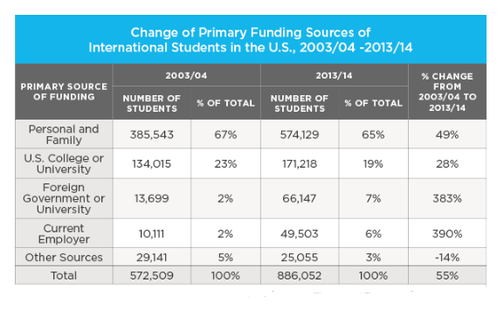

Overview: both years received money mainly from Personal and Family >< Current employer

Body 1: describe 2003/04

* Higest: personal + family / followed by U.S…
* Lowest: 2% - current employer + foreign government

Body 2: describe 2013/04

* Higest: personal + family

>< University, Current Employer and Other Sources were only 7%, 6% and 3%,

Bài làm lần 1

Em học kĩ cách viết dạng table<https://www.ieltstutor.me/blog/table>

Given is the table illustrating the US international students’ main funding sources from 2003/04 to 2013/14.

Overall, it is clear that students in both years received money mainly from Personal and Family; by contrast, funding from Current Employer to students during those time was significantly lower.

**=> mình nên viết overall theo cả hàng ngang lẫn dọc luôn nhé VD ở đây mình có thể bổ sung là số liệu đa số đều tăng qua các năm (trừ số liệu của other sources) --> there was more primary financial assistance for these students between the years, with the aids from foreign governments and current employers exceptional.**

**đọc kĩ:** [**https://www.ieltstutor.me/blog/table**](https://www.ieltstutor.me/blog/table)

In 2003/04 , there were 385,543 students (or 67%) got funding from Personal and Family, which was the higest; and the figure for U.S College or University were 134,015 students (23%) On the contrary, only 2% of students in that year were funded by Current Employer. Similarly, the money invested from **foreign government or** university only for 13,699 students (or 2%).

In 2013/14, the number of students getting money from Personal and Family hit the peak at 547,129 ( 65% ) among other sources; followed by 171,218 students funded by US college or University. Conversly, the figures for Foreign Government or University, Current Employer and Other Sources were only 7%, 6% and 3%, respectively. ( 160 )

⇒ Chia bố cục như này cũng đc nhưng quan trọng là mình chưa nói cái số liệu % change nha cái này sẽ bị trừ điểm nặng